I Sought the Lord & He Answered Me
September 30, 2018

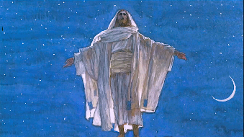
I sought the Lord, and He answered me
He delivered me from all of my Fears.
The storm winds raged, and He silenced them
He delivered me from all of my fears.

The lions roared, in the dead of the night
You set me on high from my violent foes.
I wandered off in my prideful ways
So gently, you convicted my soul.

The Lord is near to the broken of heart
He heals the crushed and forlorn.
If you have sinned Jesus waits for you
To forgive and restore your soul.

Oh, what He’s said, He surely will do
Oh, love the Lord! He cherishes you.
He longs for you in the still of the night
Go swiftly to Him, His heart waits for you.

My mind grew dim, so He anointed me,
And restored the joy of my life.

Watch the skies, for He’s coming soon
To sweep you up and into His arms.
(shofar plays)
I sought You, Lord, and You answered me
You delivered me from all of my fears.

